Analysis on 360 Brass and 1018 Steel Mechanical Properties under Cold-Working and Annealing

Authors: Delara Esfarjani, Henry Glover, Oliver Palafox, Monse Vega

Abstract
The purpose of this experiment is to observe and gain insights into the changes of mechanical properties of 360 brass and 1018 steel under work hardening and annealing processes. Brass underwent work hardening with a series of 2, 4 and 6 turns using a rolling mill with a Vickers test performed to measure the indent of each. From this process, the brass increased in yield strength and tensile strength, while it decreased in ductility and work of fracture as %R increased. Then, both brass and steel were annealed, and through performing Vickers hardness testing on the annealed brass and tensile testing on the cold worked and annealed steel sample, the influence of annealing was shown. Brass depicted a decrease in yield strength from the hardness test. Steel depicted a lower yield strength, tensile strength, and higher ductility for the annealed sample compared to the cold worked sample. Steel displayed a higher yield strength after the work hardening process and lower change in strength from the annealing process compared to brass. Overall, work hardening and annealing led to insights into the material properties of 360 brass and 1018 steel as well as the real-world applications of these processes.

1. Introduction

To understand the mechanisms of deformation and recovery in crystalline materials, a series of experiments were conducted to analyze the mechanical properties of 360 brass and 1018 steel. Two key processes in this context are work hardening, specifically through rolling, and annealing, both of which influence the behavior of the materials under stress. The inner workings of a material’s structure are based on the arrangement of atoms within the crystal lattice. A dislocation is an irregularity within that structure, allowing atoms to shift from their arranged positions abruptly. This shift leads to slip, where the movement of dislocations enables atoms to slide over one another [3]. As the density of dislocations increases, the strength of the metal also increases. This is because the dislocations come closer together, causing their stress fields to interact. As a result, the motion of dislocations becomes more difficult [1].

  - Work Hardening

Work hardening is a process in which a material is strengthened during plastic deformation because of cold-working. In this experiment, 360 brass samples were cold-worked by rolling (2 turns, 4 turns, and 6 turns) and analyzed. Hardness tests can be used to estimate a materials strength and are employed after the rolling process. This portion of the experiment will be used to assess the influence of work hardening on strength by comparing hardness values for samples after imposing various amounts of strain [1] [2].

To implement cold working in the 360 brass sample, rolling is used to decrease the thickness of the sample material. The amount of work hardening in a sample undergoes can be quantified as a percent reduction in the following formula:

$$\begin{aligned}\%R= \frac{t_{o}-t_{f}}{t_{o}}×100 \#(1)\end{aligned}$$

where $t_{o}$ is the initial sample thickness and $t_{f}$ is the final thickness after rolling. Based on the sample dimension, the true strain is also calculated in the following formula:

$$\begin{aligned}ε_{T}=ln\frac{t_{o}}{t_{f}}\#(2)\end{aligned}$$

The rolled samples are subject to a Vickers hardness test before and after the cold working had happened. A 300-gf load was indented on the samples and inspected by a set of x-y stage control micrometers where an average diameter was calculated using the following formula:

$$\begin{aligned}\frac{d_{1}+d_{2}}{2}\#(3)\end{aligned}$$

where $d_{1}$ is the diameter in the x-direction and $d_{2}$ is the diameter in the y-direction. The average diameter was then used to find the Vickers hardness number using the formula:

$$\begin{aligned}HV= \frac{1854.4 F}{d_{avg}^{2}}\#(4)\end{aligned}$$

where F is the 300-gf and $d_{avg}^{2}$ is the average diameter. HV is converted into MPa and an estimated yield strength for each sample is found using the formula:

$$\begin{aligned}σ_{y} ≈ \frac{9.807 HV}{3}\#(5)\end{aligned}$$

The equations allow us to characterize the extent of the cold-worked samples and allow for us to estimate strength using the Vickers Hardness test. The data was used to compare strength values for 360 brass. A baseline strength test, cold-worked samples that were rolled, and annealed samples were tested [1].

  - Annealing

After completing the analysis of the cold-worked sample, an annealing heat treatment was applied following work hardening. This process aimed to relieve internal stress, refine the grain structure and boundaries, and enhance the material's ductility. While the annealing process reduces the overall strength of the sample, it significantly increases ductility, allowing for further shaping of the material. To anneal the sample, the metal is heated to a constant temperature and held for a specified duration. In this experiment, 360 brass samples were subjected to an annealing temperature of 500 °C for 1.5 hours, followed by Vickers hardness testing [1].

An annealing heat treatment works by reducing the dislocation density in a cold-worked sample and restores the grain structure to an equiaxed form. It is important to note that annealing is more effective with samples that have undergone extensive cold-working. The annealing temperature is typically set at approximately 0.4 to 0.6 times the melting temperature. The process consists of three main stages. Recovery, where the samples internal energy is relieved by dislocation rearrangement. Recrystallization, where a new set of low dislocation density equiaxed grains form caused by the reduction of internal energy. Lastly, grain growth, where reducing the internal energy leads to a reduction in grain boundary area and leads to new grains [1].

Tensile testing was also conducted on two samples of 1018 steel: one that had been cold-worked and another that was fully annealed. The tensile test provides detailed insights into the properties of both the annealed and unannealed metals. It outputs a stress-strain curve and facilitates the comparison of key metrics such as modulus, ductility, and work of fracture. The expected results should indicate a decrease in strength for the fully annealed sample, along with an increase in the ductility curve [1].

2. Materials and Methods

2.1 Materials
- Brass (360) – bar stock
- Steel (1018) – dog-bone sample
- Rolling Mill
- Hardness tester
- USB optical digital microscope – Obtain images of failed tensile samples
- Measurement calipers
- Load Frame
  - Pasco Capstone Software- Displacement vs Load
2.2 Methods

2.2.1 Work hardening

360 brass samples were received and indented four times in their "as received" condition. The samples were polished beforehand by the TAs and then subjected to a series of Vickers hardness tests. Each sample was placed polished side up, with the magnification set to 50x and the stage adjusted to ensure the lens was 1 cm from the sample. The load was set to 300 gf, which created a small indent in the metal. To visually observe the indent, the microscope used was equipped with a built-in micrometer that measured both the horizontal and vertical dimensions of the indent. This process was conducted four times before the metal was cold-worked and four times after.

To cold-work the samples, a rolling mill, as shown in Figure 1, was used to perform plastic deformation. The brass bar stock was rolled multiple times to achieve increasing amounts of work hardening. The sample underwent a series of reductions: 2 turns, 4 turns, and 6 turns. Before rolling, the initial thickness of the sample was measured using calipers. The sample was then passed through the rolling mill, with the roller spacing reduced by a quarter turn of the T-handle between each pass. After several passes, the sample was rotated and flipped to ensure uniform pressing. Thickness measurements were taken after each reduction, allowing for the calculation of percent reduction and true strain. After two reductions, a portion of the sample was cut and labeled, and this process was repeated for a total of 4 and 6 reductions.
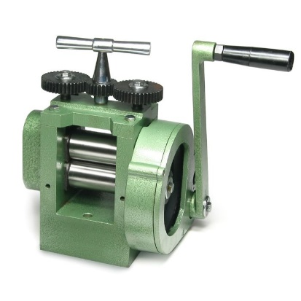
- Rolling mill with the T-handle at the top of the machine and the crank handle located to the right.
2.2.2 Annealing

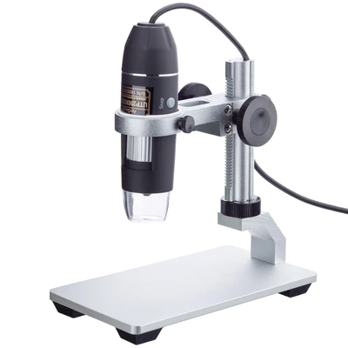
The 1018 brass samples that had been previously rolled were fully annealed at a temperature of 150 °C for 1.5 hours. A series of Vickers hardness tests were conducted, with a total of four indentation measurements taken to compare strength values against the "as received" and cold-worked samples. Additionally, two 1018 steel samples—one fully annealed and one fully cold-worked—were tested to failure in a load frame under tension, following the application of a 100 N preload. The dog-bone samples were securely mounted by screwing the shorter side into the bottom load cell and tightening the load bar nut. Using Pasco Capstone software, the load was gradually increased to 100 N, then reduced and increased multiple times to ensure proper seating. Once confirmed, the test began, with the crank turned at a rate of 10-20 mm/min until the sample fractured. Data was recorded, and the process was repeated for both samples. Imaging of the necking in the steel samples was performed using a digital microscope, as shown in Figure 2, to compare the differences between the cold-worked and annealed samples.

- USB digital Microscope used to take images of the 1018 steel sample to observe its structure and composition.
3. Results

Below are the values of true strain and percent reduction in area of the brass samples under cold working.

Indent # | 1 |  |  | 2 |  |  | 3 |  |  | 4
 | %R | ε_{t} | σ_{y} (MPa) | %R | ε_{t} | σ_{y} (MPa) | %R | ε_{t} | σ_{y} (MPa) | %R | ε_{t} | σ_{y} (MPa)
As received | 0 | 0 | 376.4 | 0 | 0 | 379.2 | 0 | 0 | 346.5 | 0 | 0 | 389.3
2 turns | 2.848 % | 0.03 | 465.6 | 2.848 % | 0.03 | 488.7 | 2.848% | 0.03 | 488.7 | 2.848% | 0.03 | 376.5
4 turns | 13.70 % | 0.147 | 579.9 | 13.70% | 0.147 | 550.1 | 13.70% | 0.147 | 341.3 | 13.70% | 0.1474 | 529.6
6 turns | 24.17 % | 0.277 | 584.1 | 24.17% | 0.277 | 565.7 | 24.17% | 0.277 | 596.8 | 24.17% | 0.277 | 588.3
- This table presents the values of percent reduction in area and true strain for brass samples under various cold rolling conditions, illustrating how deformation impacts material properties at each stage of processing.

Now, the estimated yield strength for brass cold worked is depicted alongside the estimated yield strength of annealed brass.

- This graph presents the influence of cold working on brass samples, including the as-received condition (true strain = 0). Each data point represents the mean strength from group measurements, with error bars showing standard deviation. No lines connect the data points to emphasize the discrete nature of the measurements across different cold working conditions.

Indents were placed onto the brass cold worked sample, thus, here is the visual of each indent under each condition.

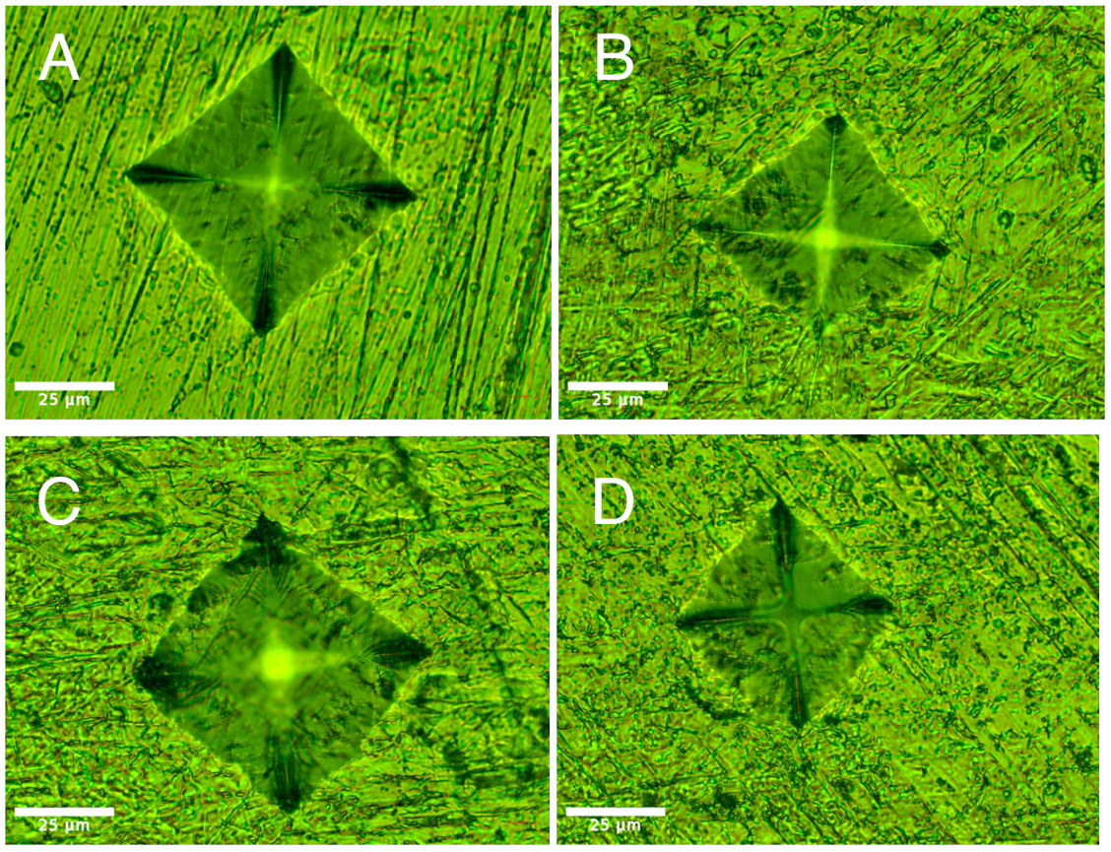
- This multipart figure displays indents made on the cold-worked brass material under four conditions: (a) as received, (b) after 2 turns, (c) after 4 turns, and (d) after 6 turns. The scale for all images is equivalent because the images were taken at the same magnification level.

Now, these are the indents on the annealed brass sample.

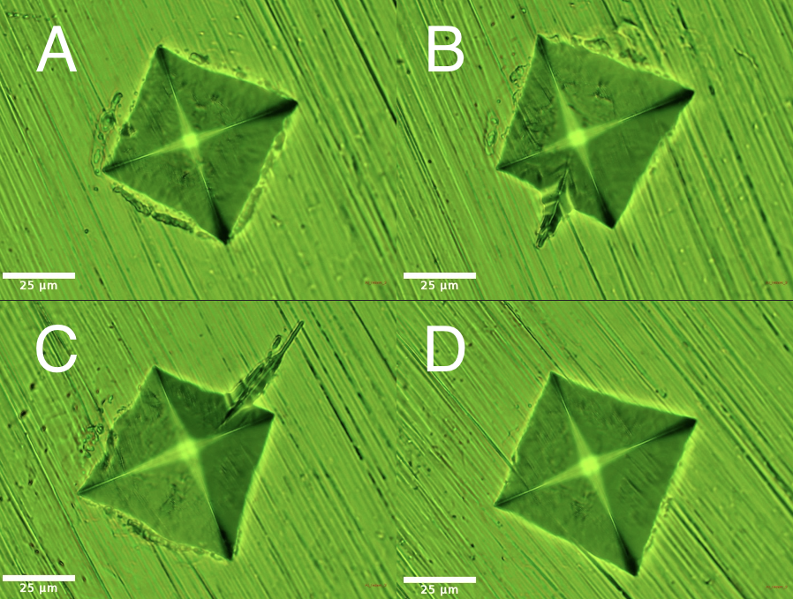
- This multipart figure displays indents made on the annealed brass material: (a) indent 1, (b) indent 2, (c) indent 3, and (d) indent 4. The scale for all images is equivalent because the images were taken at the same magnification level

- The graph compares the stress-strain behavior of cold worked and annealed 1018 steel, highlighting the increased yield and tensile strength of the cold worked sample and the greater ductility of the annealed sample.

For 1018 steel, both the cold worked and annealed samples underwent tensile testing. In Figure 6, the stress strain curves are depicted. In Figure 7, the visual of the fractured samples is shown.

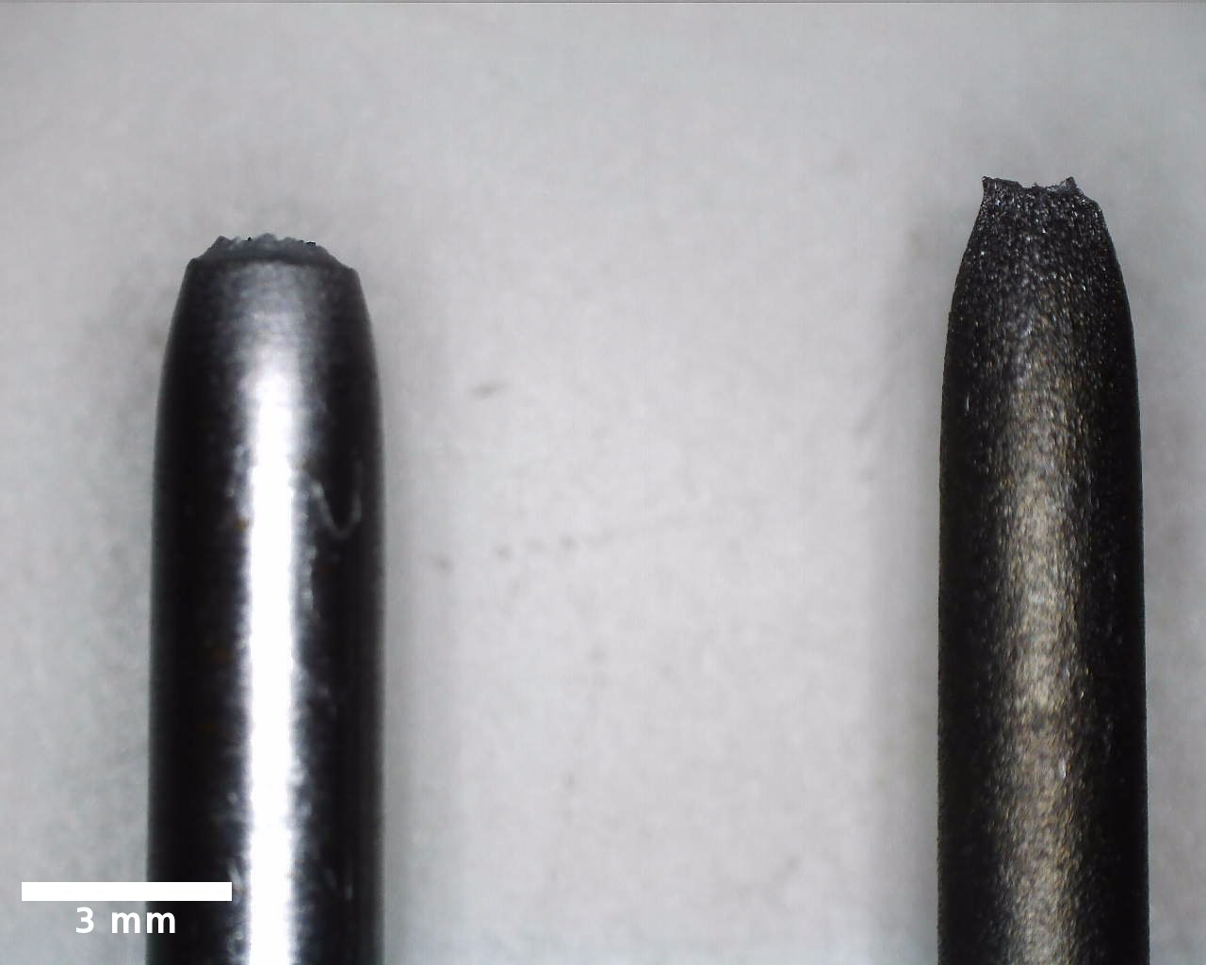
- The image shows failed tensile steel samples under the microscope, including a scale bar for reference. Diameter measurements are indicated to illustrate the reduction in cross-sectional area at the fracture point.

Here are the values of the properties for cold worked and annealed 1018 steel.
- The key tensile properties of cold worked and annealed steel, including Young's modulus, yield strength, tensile strength, ductility, and work of fracture. For the cold worked sample, the yield strength was determined using the 0.2% offset method due to the absence of a clear yield point. For the annealed steel, the lower yield point is taken as the yield strength due to the observed yield drop.
 | Young’s Modulus (GPa) | σ_{y,0.2} (MPa) | σ_{TS} (MPa) | Ductility %EL | Work of Fracture (MPa)
Cold Worked | 202.20 | 715.00 | 821.37 | 6.88 | 54.81
Annealed | 157.07 | 265.00 | 378.66 | 36.47 | 124.62

4. Discussion
4.1 Work Hardening Vickers Hardness Data Analysis:
Looking at the data table from the cold-worked pieces of brass, we can see the numerical results of our work hardening. The most notable difference between each condition of cold-worked brass (as received vs. 2 turns vs. 4 turns vs. 6 turns) is the scaling in yield strength. The data shows the most significant increases of yield strength when transitioning from as received to 2 turns, and 2 turns to 4 turns. The yield strength values from 4 turns to 6 turns only saw small increases.
Another relevant piece of data from the table is %R and its relationship to mechanical properties such as yield strength. We can see that %R increases by around the same amount from 2 turns to 4 turns and from 4 turns to 6 turns (~10.66%), yet the yield strength increases differently each time. As previously stated, we see a much larger increase in yield strength from 2 turns to 4 turns compared to from 4 turns to 6 turns.
Analyzing the microscope images from the cold-worked brass, we can see a decrease in indent size each time, going from as received to 6 turns. This proves an increase in material hardness with increasing cold work.
The data table and the microscope images together show us that certain mechanical properties, specifically strength (yield, tensile) and hardness both increase with an increase in cold work and vice versa. This is due to the increase in dislocation density because of work hardening. As dislocation density increases, it drives the increase of strength and hardness, while decreasing ductility. Atomic properties such as elastic modulus and coefficient of thermal expansion remain the same throughout because their change relies on the altering of atomic bonds.
4.2 Annealing Vickers Hardness Data Analysis:
The microscope images of the annealed brass sample show us the effects of annealing on a work hardened material. The shape and size of the indents for the annealed brass resemble that of the as received brass sample from the work hardening section. This shows the ability of annealing to return a cold-worked material to its original stress. Annealing happens in three stages (recovery, recrystallization, grain regrowth), with recovery being the most significant part in the process. During recovery, the internal stresses and dense dislocations are relieved leading to a reversal in the cold working process. This restores the pre-cold-worked mechanical properties. As a result of annealing, the hardness and strength decrease while ductility increases because of the decrease in dislocation density.
4.3 Annealed Tensile Test Data Analysis:
The tensile tests performed on the cold-worked 1018 Steel and annealed 1018 Steel further display the effect of work hardening and annealing on mechanical properties. Looking at the graph in Figure 4 alone, we can very obviously tell that the cold-worked sample has much greater strength than the annealed sample, while the annealed sample shows greater levels of strain at fracture. This is supported by the data entered in Table 2. Through the images shown of the fracture points of each sample we can also see that the annealed sample has a smaller cross-sectional area, suggesting that it underwent greater levels of plastic deformation and necking before fracture. This displays its greater ductility than the cold-worked sample.
Also, as seen in the Figure 4, there is relatively the same Young’s Modulus between the cold-worked sample and the annealed sample. As previously mentioned, modulus only changes with the change of atomic bonds, and because those bonds were not altered, the elastic modulus remained very close between the two samples.
Overall, the 0.2% offset yield value of the cold worked-sample was greater than the annealed sample by ~270% and the tensile strength of the cold-worked sample was greater than the annealed sample by ~217%. The ductility was greater in the annealed sample by ~29.6%EL. Work of fracture was a bit over twice as large as the cold-worked sample in the annealed sample.
4.4 Error Analysis:
An instance of error can be found in Table 1 in our work hardening portion. For the 4th indent with 2 turns and the 3rd indent with 4 turns, we can see a decrease in yield strength instead of an expected increase from the previous yield strength values. This could be due to an error in calculations, or possibly an inconsistent indent size that led to lower yield stress values than expected. This can be solved by relying on more accurate indent data in the future and ensuring calculations are performed correctly.
Another possible source of error could be the non-perfect elastic modulus values for Table 2, which shows around a 50 GPa difference between the two samples. Although the data shows this difference, the graph in Figure 4 shows the elastic regions almost perfectly mapped on top of each other, although the precision may not be as emphasized.

5. Conclusion
The purpose of this lab is to observe the change in the material properties of 360 brass and 1018 steel from work hardening and annealing processes. Through the results, the effectiveness of these methods for engineering applications was observed. Regarding work hardening, the number of turns was shown to be proportional to the yield strength of the brass. In other words, the increase in work hardening that was performed on the brass led to an increase in specific material properties of brass. The yield strength for Indent 4 displayed a slight error since the yield strength is shown to be decreasing as %R increased rather than increasing as well. This error may have been a slight human error, as shown in Section 4.4. One way to minimize the errors within this experiment is to use manufactured material properties as a reference to identify errors when conducting the procedures. Although there were discrepancies between the manufactured and experimental values, due to factors such as inevitable dislocations within the metals, the overall trend the expected proportional relationships would still be highlighted between work hardening, yield strength, tensile strength, with an inverse relationship between ductility.
Furthermore, for the annealing procedure, the yield strength of brass was shown to decrease from annealing, while the ductility of brass was shown to increase from annealing. A few research questions were raised from this experiment. How much cold working can a material withstand and still undergo successful annealing? Since annealing does not affect the atomic bonding of a material, according to Table 2, why would Young’s modulus, an atomic level property, of 1018 steel change and is there an extent of how much the modulus can change under this process?
Overall, the influence of annealing and work hardening among material properties was observed and led to insights into the real-world engineering applications. For example, steel was shown to be stronger from not only the higher strength than brass through work hardening, but also the lower change in strength in steel compared to brass from annealing. From the results, the material properties of steel indicate its favorable properties for strong tools that are low in ductility. On the other hand, the higher ductility of brass and greater change in strength from annealing, compared to steel, indicates its favorable properties for somewhat strong tools with high ductility. To conclude, in this experiment, the effectiveness of observing the material properties from annealing and work hardening was highlighted and thus, shown to be applicable to real world applications.

References

[1] MASC 310L Lab Manual, Fall 2024

[2] MASC 310L Lecture Notes, Fall 2024

[3] V. Vitek, “Dislocations,” Encyclopedia of Condensed Matter Physics, pp. 404–410, 2005. doi:10.1016/b978-0-323-90800-9.00320-6

